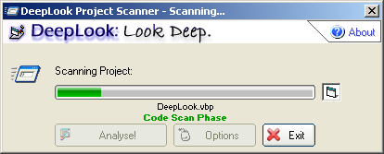

What exactly is a “hybrid line”?
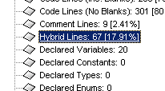

A hybrid line in DeepLook refers to a line that contains both code and comments. I made the distinction between pure code lines and pure comment lines because a line containing both is neither one nor the other.

Why do the percentages add up to more that 100%?!
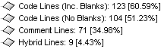

If you add up the above percentages, you will get a number over 100%. This is not a bug however; the percentages are of the total code. Therefore, because Code Lines (No Blanks) is a subset of Code Lines (Inc. Blanks), it is not counted. The total percentage for each file is made up of the Code Lines (Inc. Blanks), Comment Lines and Hybrid Lines.

Where are my “Used Fonts” located?
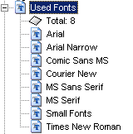

The Used Fonts node contains the fonts used by controls in your project. Because fonts exist as plain text strings in code, it is impossible to determine these separately and consequently they are not included.

Why do some DLLs show with a little Windows logo?
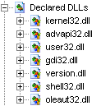

This indicates that DeepLook has identified the DLL in question as a standard DLL included with Windows. This is not important until you copy the files required by a project; these system files are omitted.

Why are benign commands included as “Potentially Malicious”?
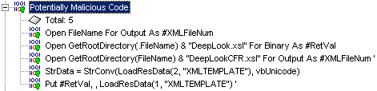

This is due to speed. The DeepLook malicious code scanner is not designed to be extremely accurate; it is built for speed. I decided that more false positives in a fraction of the time is a better option.

Why are the sub, function and property names in different colours?
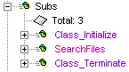

The colours indicate the type and scope of the sub, function or property. If you look at the top of the DeepLook form, you’ll see a key which indicates what each colour means.

Why are two files required for the XML reports?
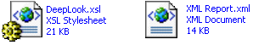

Both files are necessary to view the reports, and they need to be in the same folder. The .xsl file is the XML formatting sheet, which tells your browser how to format the raw data contained in the .xml file. You need to open the latter to view the report, not the former.

How and why are the number of controls counted?
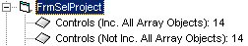
VB imposes a limit on the number of controls you can place on a single form, user control etc. This number does not include control array elements and so both the total number of controls (Controls (Inc. All Array Objects)) and the number of controls (arrays are counted as a single control) Controls (Not Inc. All Array Objects) are shown.

